BEEE LAB EVALUATION

**Aim :** To design a visitor counting system with the help of LDR for a hall .

**Circuit Diagram:**

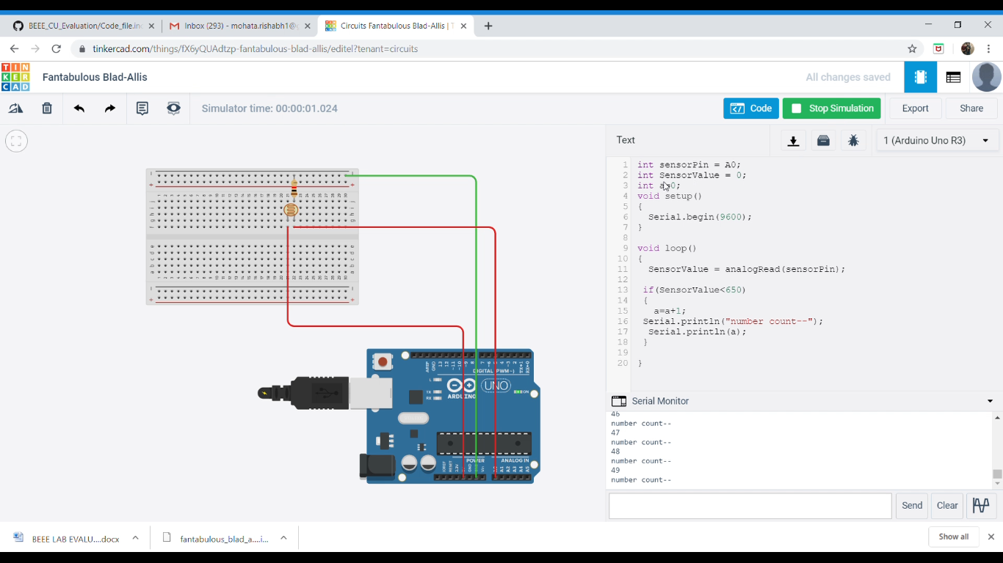

**Theory:**

A Light Dependent Resistor (LDR) is also called a photoresistor or a cadmium sulfide (CdS) cell. It is also called a photoconductor. It is basically a photocell that works on the principle of photoconductivity. The passive component is basically a resistor whose resistance value decreases when the intensity of light decreases. This [**optoelectronic device**](http://www.circuitstoday.com/optoelectronic-devices) is mostly used in light varying sensor circuit, and light and dark activated switching circuits. Some of its applications include camera light meters, street lights, clock radios, light beam alarms, reflective smoke alarms, and outdoor clock.

The **Arduino Uno** is an open-source microcontroller board based on the Microchip ATmega328P microcontroller and developed by Arduino.cc. The board is equipped with sets of digital and analog input/output (I/O) pins that may be interfaced to various expansion boards (shields) and other circuits. The board has 14 Digital pins, 6 Analog pins, and programmable with the Arduino IDE (Integrated Development Environment) via a type B USB cable. It can be powered by the USB cable or by an external 9-volt battery, though it accepts voltages between 7 and 20 volts.

**Concept Used:**

The Light intensity is being calculated using the LDR , as the light intensity gets below the standard value then the count of visitors increase on the serial monitor.

**Learning and Observations :**

* Making circuits using Breadboard.
* Using Multimeter to apply Resistance on a given LED.
* Working of Arduino UNO.
* Coding to be done on Arduino.exe for stimulation of the experiment.

**Problems & Troubleshooting –**

No problems were occurred during the execution of the experiment.

**Precautions –**

1. The circuit made on breadboard can be wrong.
2. Any Element used can be defective.
3. Resistance of high value used therefore resulting in no current for LED to glow.
4. The coding done for Arduino Board can be incorrect due to which stimulation can be failed.
5. Port Selection for Arduino can be incorrect due to which it wont upload on Arduino Board and resulting in failure of experiment.

**Learning Outcomes –**

1. Setting up circuit on a Breadboard.
2. Using Multimeter.
3. Working and coding of Arduino and its IDE.
4. Using LDR and learning its features .

**Result :** The system made is able to count the visitors in a hall entering through a door with the help of a LDR .